Obtaining and observing conidia

*Obtaining primary conidia*

To obtain primary conidia, we use the following "descending conidia" showering method (Fig. 1):

- place the dead insect, either suspected to be killed by an entomophthorale (and then surface sterilized) or bearing conidiophores already, on a moistened piece of filter paper, tissue or paper towel,

- for a large cadaver, cut it in several sections and prepare sections separately as for a whole insect,

- attach that moistened piece to the inside of a small Petri dish lid,

- invert the lid over the base of the Petri dish where a coverslip was placed, or directly over a slide,

- collect conidia on several coverslips or slides for period of various lengths, according to the intensity of sporulation.

- use the cadaver for subsequent isolation of the fungus, observation, and/or storage.

These coverslips or slides would be used separately for observation of primary conidia, obtention of secondary conidia (see below), and conservation for collection purposes. In any case, it is not necessary to get a huge amount of conidia on a coverslip or a slide. About 200 to 300 conidia are sufficient per item. Indeed, the period of time during which conidia are collected should be as short as possible. This prevents the fungal structures to develop too much, and helps to keep nice morphological structures for further observation.

An alternative method is the "ascending conidia" showering method, which is illustrated in Fig. 2 (Keller 1994).

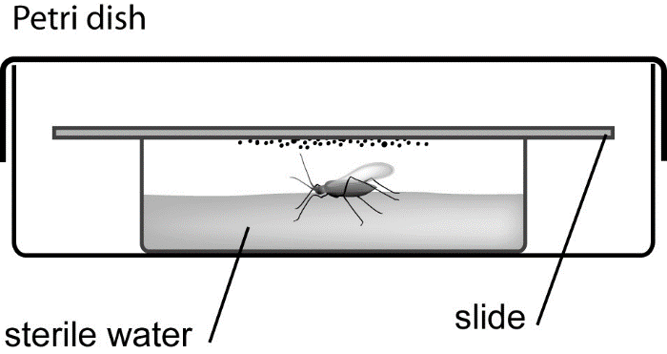

**Fig. 2.** Procedure for collecting primary conidia from an entomophthorale-infected arthropod using the "ascending conidia" showering method.

*Obtaining secondary conidia*

To obtain secondary conidia, the coverslips or slides bearing freshly collected primary conidia (less than 12-hour-old) are placed in humid conditions, e.g. by inverting over the conidia a lid or a base of a Petri dish with a moistened piece of filter paper, tissue or paper towel attached to it (Fig. 3). When this method is used primary and secondary conidia are on the same slide. To be able to distinguish between primary and secondary conidia it is important to mount the conidia when the secondary conidia are fully developed but not yet projected. Obtention of secondary conidia can be difficult to achieve with this method. In such a case, slight changes of relative humidity (e.g. by modifying the distance between the moistened paper and the conidia) could be managed to try to get the expected development from the primary conidia. Better results can be obtained when the slide with the primary conidia is placed in a humid Petri dish with a second slide placed above in a distance of 1-2 mm. The projected secondary conidia will be collected on this slide.

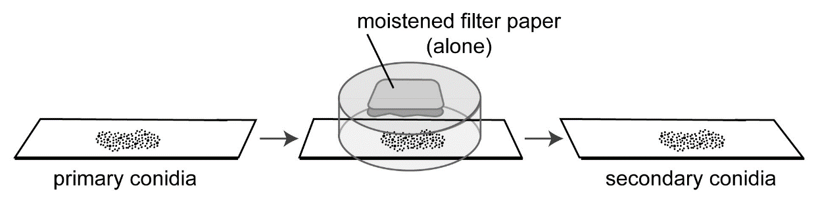

**Fig. 3.** Procedure for obtaining secondary conidia from primary conidia of Entomoph-thorales.

When cadavers are placed on the surface of water to project conidia by the ascending method (Fig. 2) primary conidia also land on the water surface where they usually start to form secondary conidia. After a few hours they can be picked up with a slide.

Observing conidia

Once collected on slides, conidia could be kept in dry conditions for long periods but it is definitively better to observe them rapidly.

For microcopic observations, conidia are mounted in a mounting medium. It is highly recommended to use only small amount of mounting medium, in order to avoid it to spread outside the coverslip when placing it on the slide.

For direct observation and measurement of conidia (a magnification of 400 x or 200 x is sufficient), the use of lactophenol added with anilin blue or cotton blue as mounting medium is recommended (for details, see below the part "Appropriate equipments and materials"). Measurements should be made on 25-50 conidia per specimen depending on the variation and on the number of available specimens.

For observation of nuclei, various staining methods should be used according to the fungal species: aceto-orcein in lactophenol, or Feulgen reaction stain (for details, see below the part "Appropriate equipments and materials"). A magnification higher than 400 x is necessary.